**T. Y. B. Tech (Electrical and Computer Engineering)**

**Trimester: VI Subject: Electric Vehicle Technology**

**Name: Shreerang Mhatre Class: TY**

**Roll No: 52 Batch: A2**

**Experiment No: 1**

**Name of the Experiment:**

**Performed on: 15/2/2024**

**Mark**

**Teacher’s Signature with date**

**Submitted on:**



**Aim:**

**Power Train Blockset**

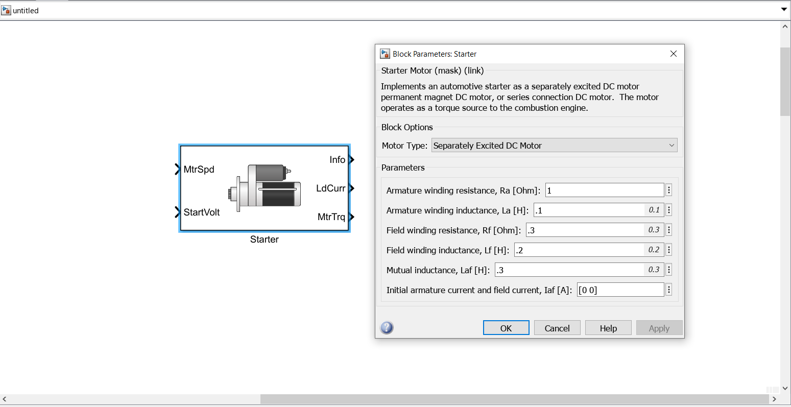

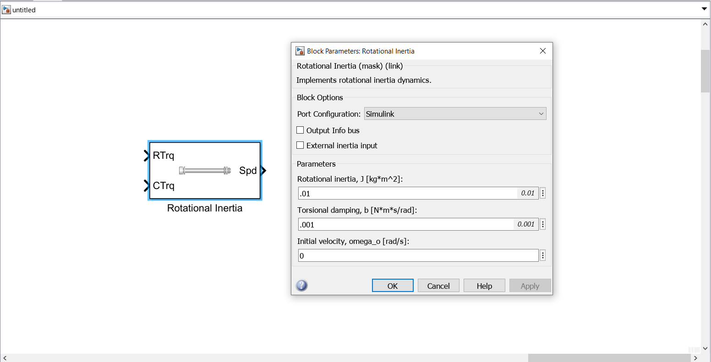

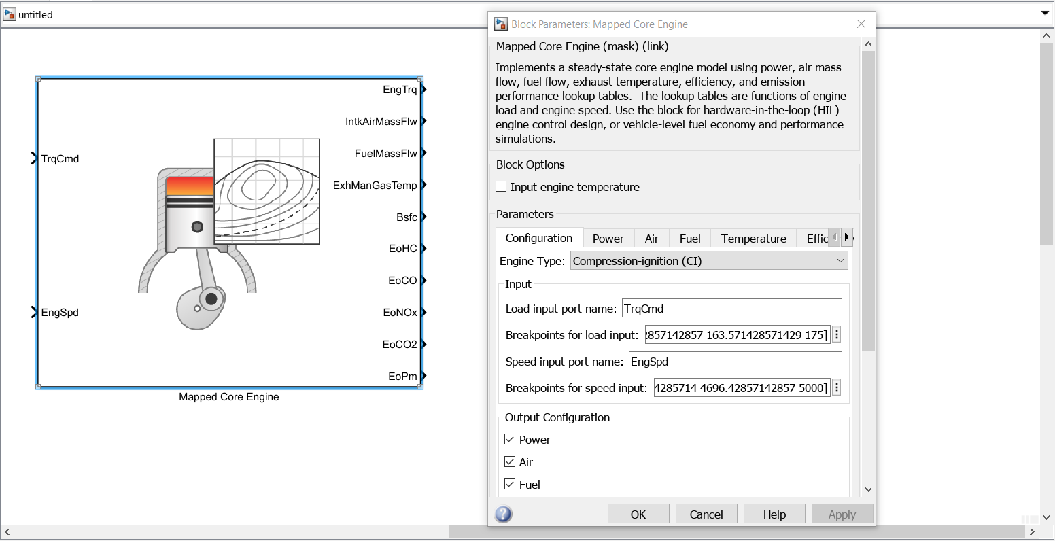

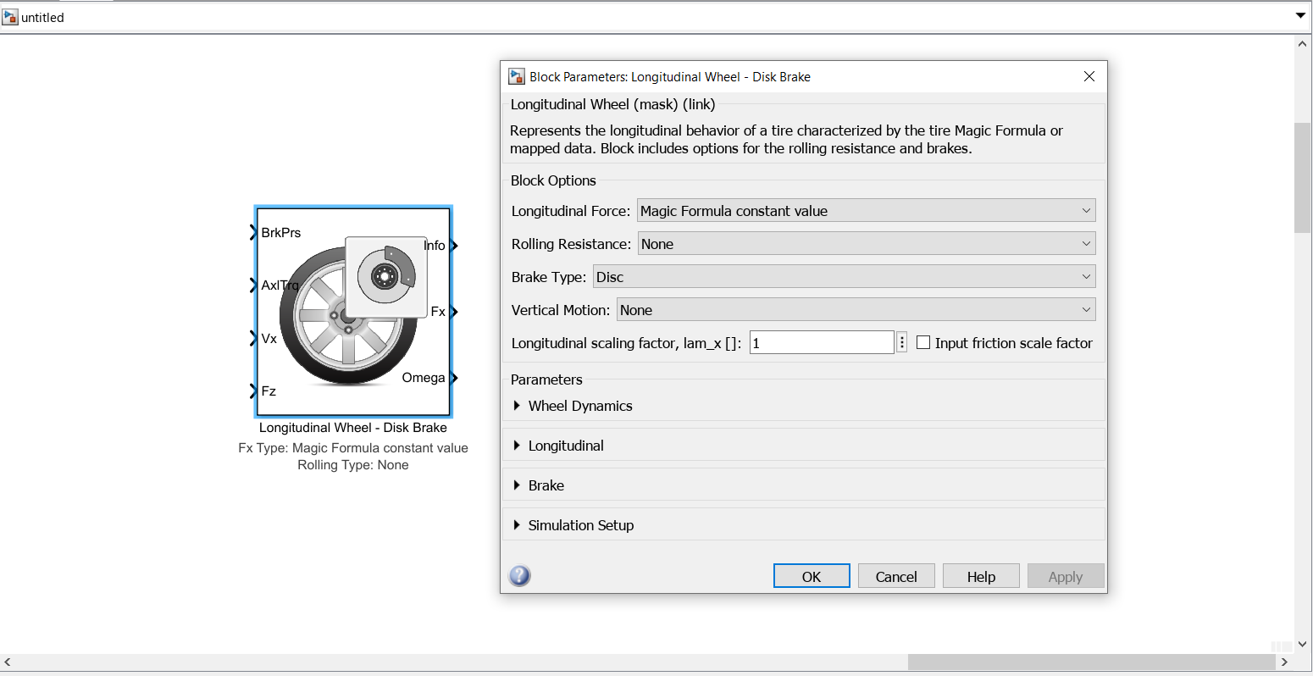

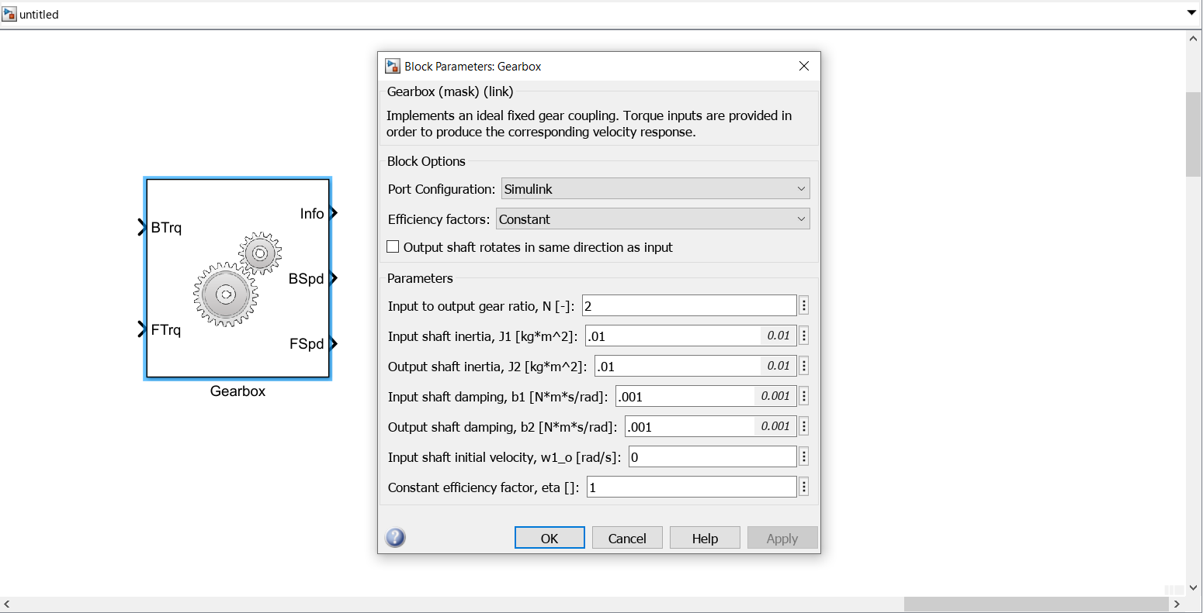

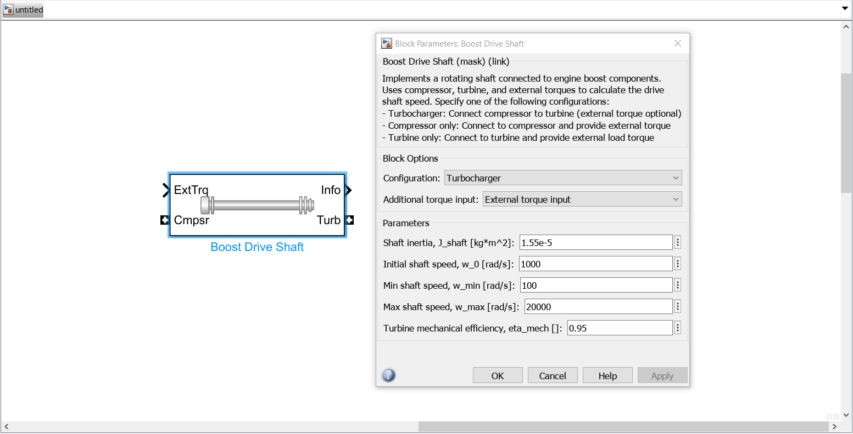

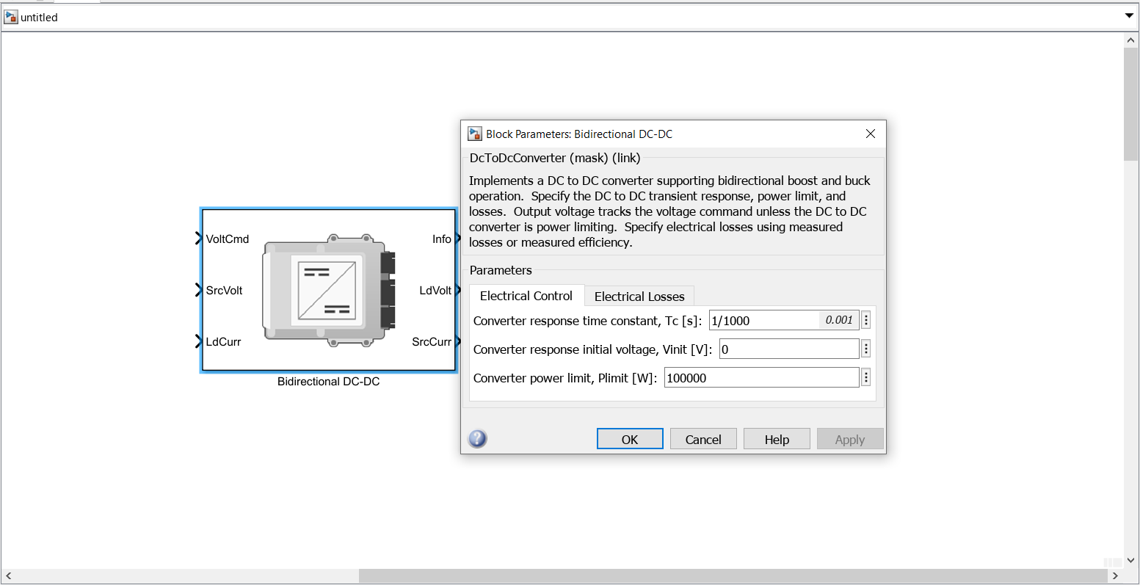

**SIMCSAPE**

1. **Battery**

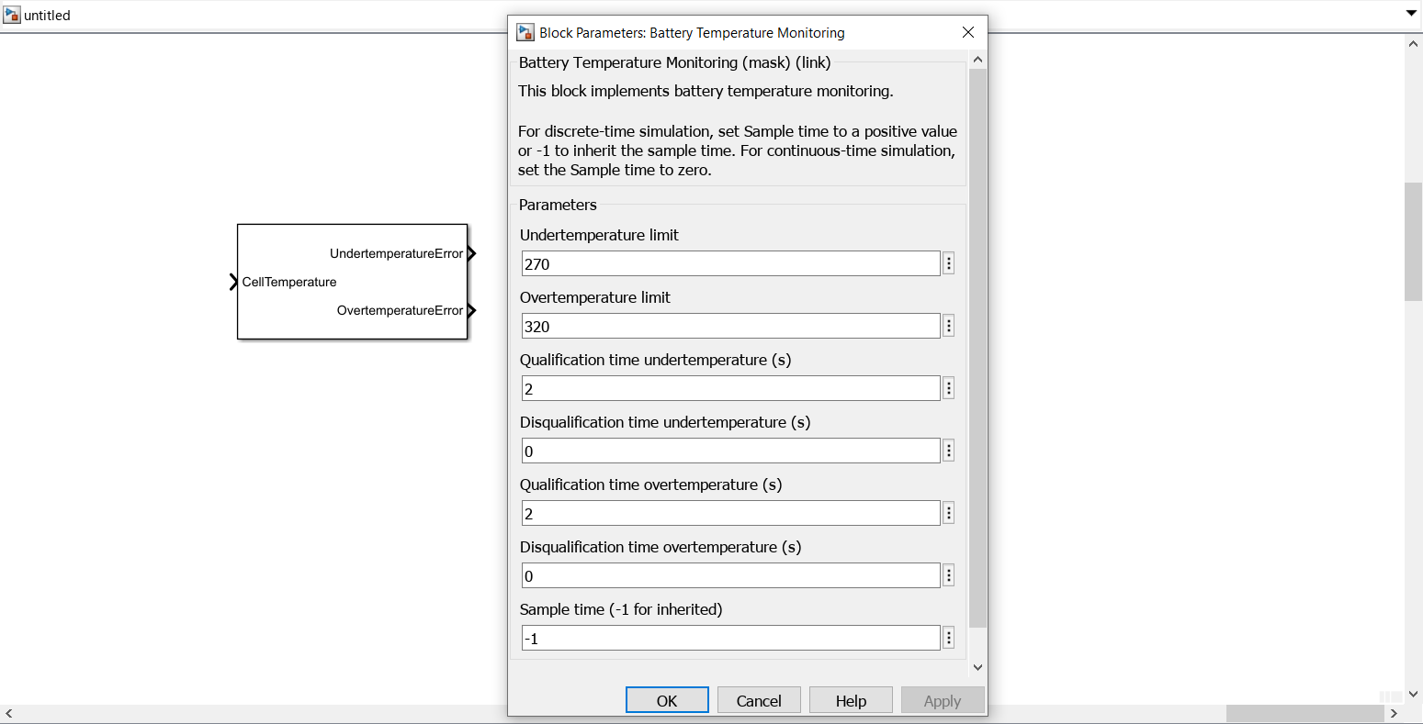

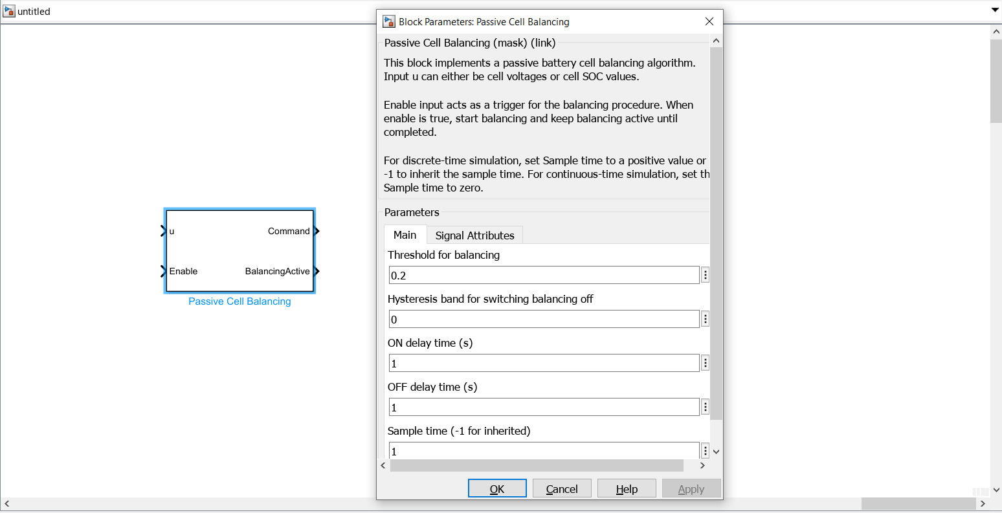

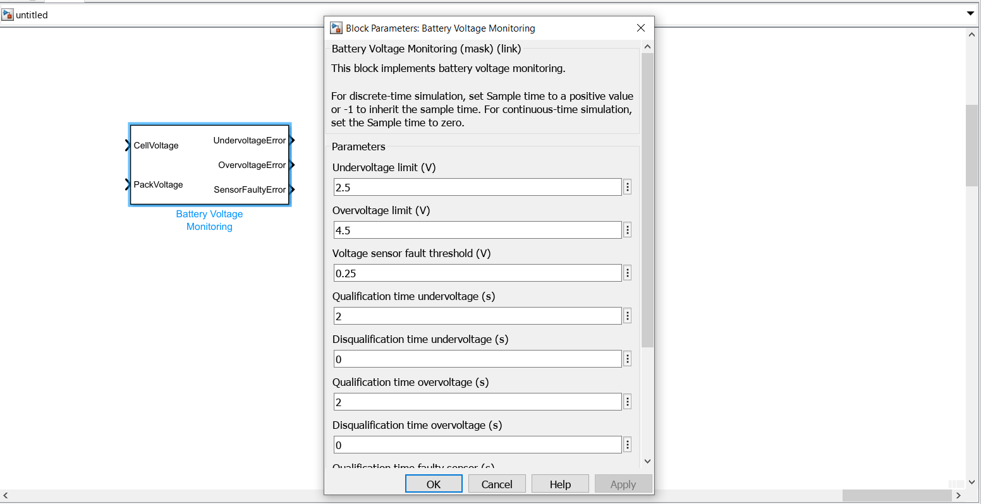

1. **Converters**

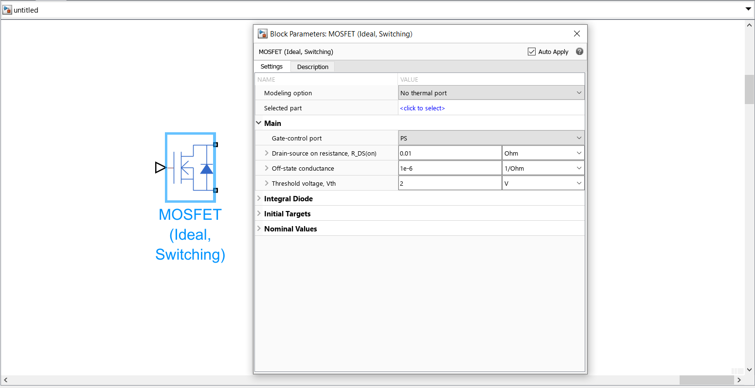

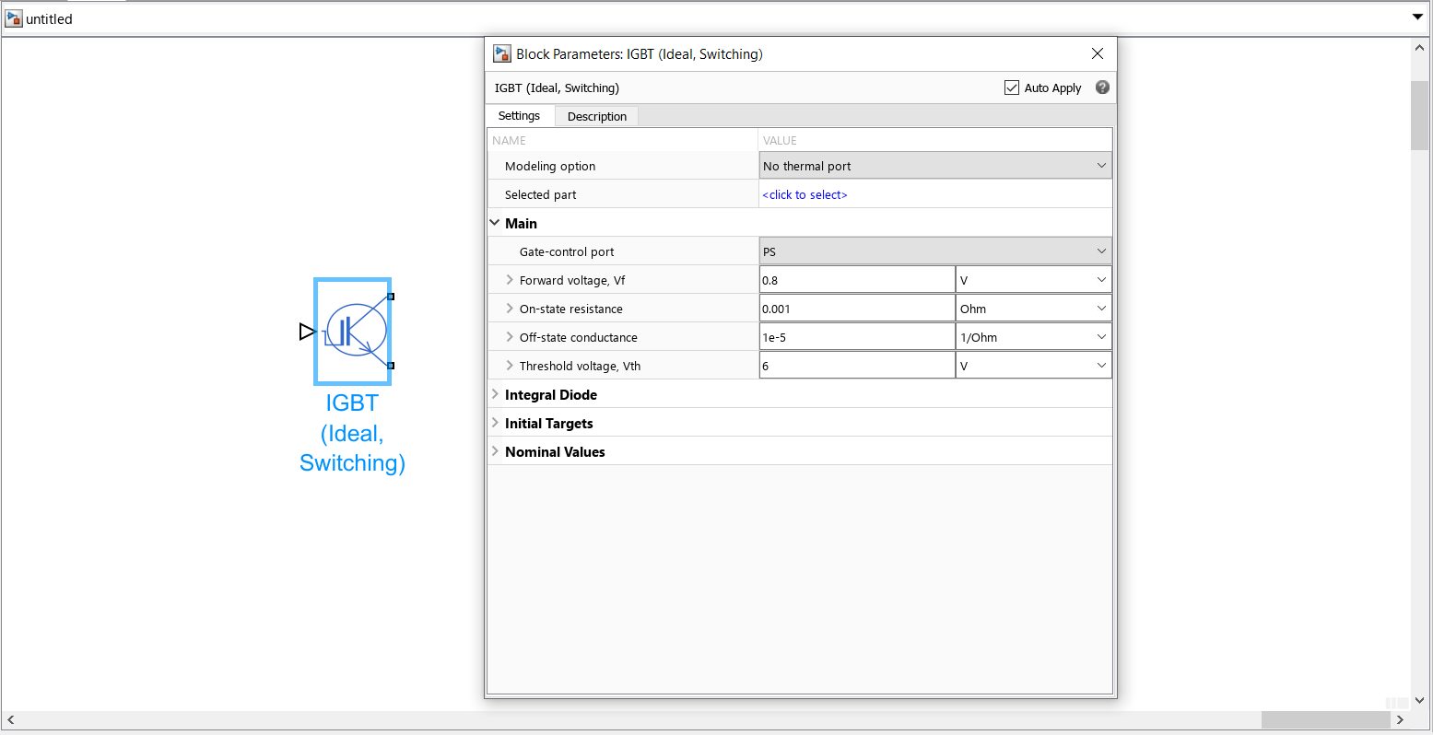

1. **Electrical**

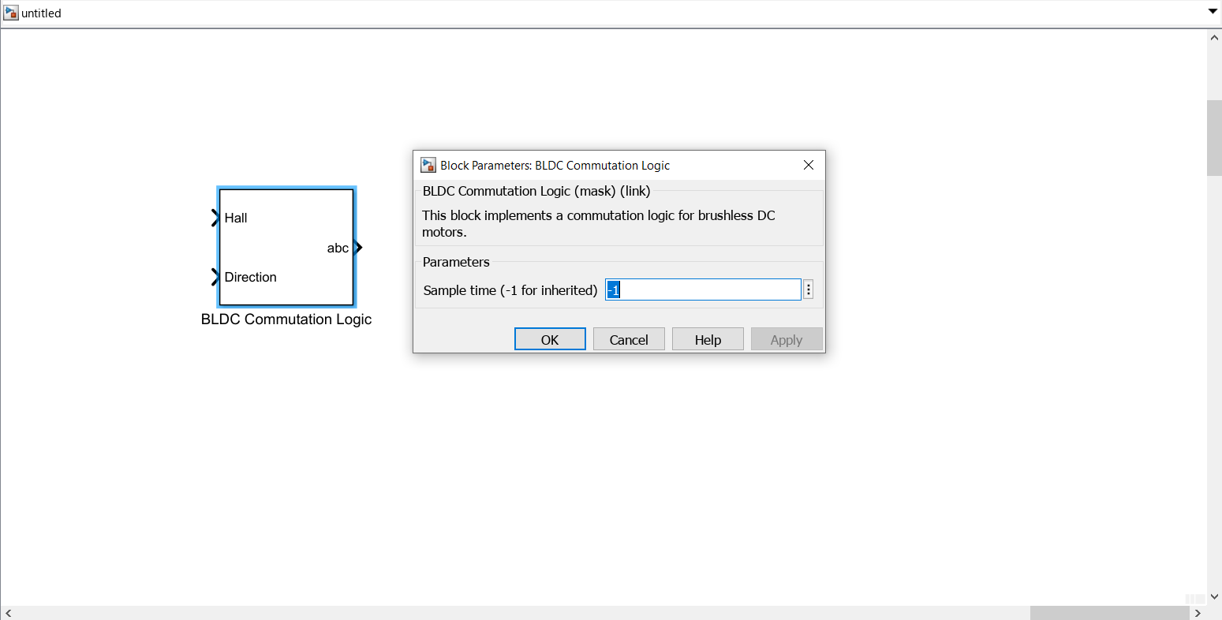

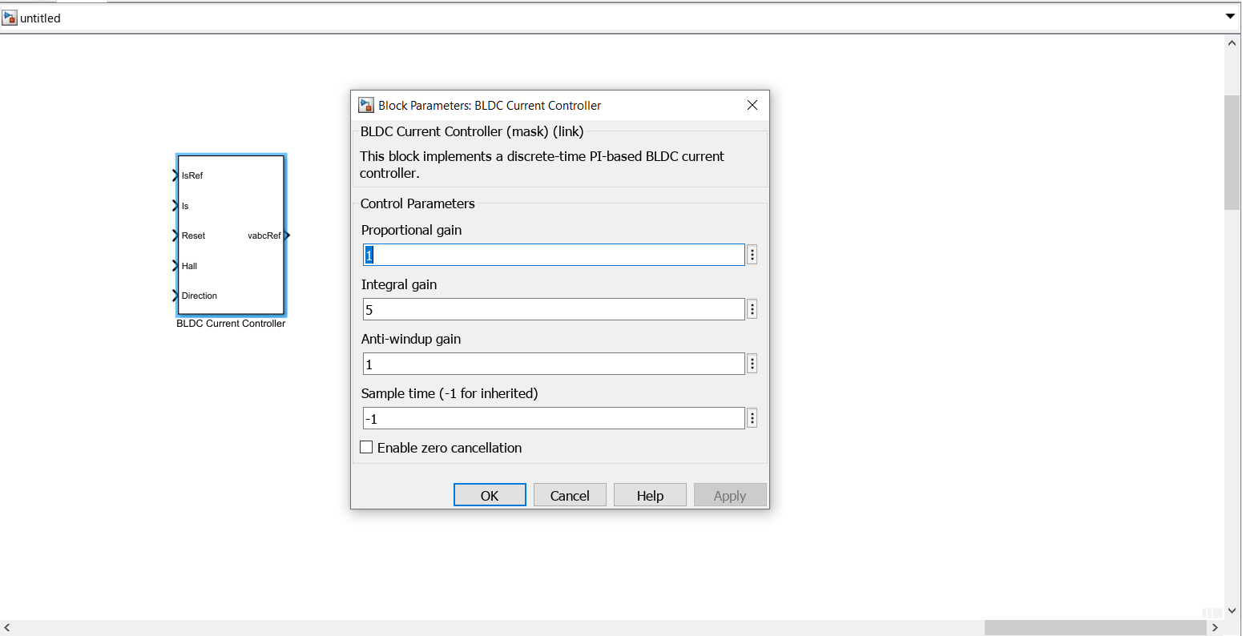

1. **Sensors**



